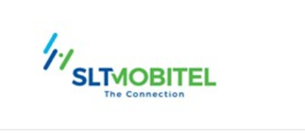

R/L/DGM/SETL/CN/053

Recovery Section,

CTO Building,

Ground Floor,

Sri Lanka Telecom PLC,

Lotus Rd,

Colombo 01.

09 03 2022

Anura Rathnayake

No:212

Pahala Biyanwila

Kadawatha

**Without Prejudice**

Dear Sir/Madam,

**Default of Payment Telephone Bills**

Outstanding Balance : 18,610.00

Telephone No : 112529183

This refers to your letter dated on the above.We are pleased to inform you that the DGM/Recoveries has taken the concern regarding to your matter and approved to resolve your matter as follows,

01) Six Installement of 3101 each

Please make arrangement to done your payments on or before 25th of each month to avoid any inconvenience.

Yours Faithfully,

Customer Care Officer,Recovery Section-Legal

Sri Lanka Telecom.

(Tel . 0113-434887)